CABRAMATTA HIGH SCHOOL

SCHOOL COUNCIL MEETING MINUTES

WEDNESDAY 11th September 2024

In Attendance

**Principal:** Mr Erskine

**Apologies**: Ms A Mikulic

**CHS Staff:** Ana Sentic, Rav Pillay, Ram Pratap

**Guest Speakers:** Rowena Assaad, Vesna Rutonjic Community Connections Manager Core community – Multicultural Communities

**SRC:** Maxwell Ly, Ethan Trejo Granados, Makkira Tous, Minh Thu Pham, Kitana Pham

**Interpreters:** Anh Vuong, Linda Siv, Monika Lychan, Widad Hanna, Ilham Mohammed, Trinh Mai and

Quoc Minh Do

**President:** Rennea Soth

**Parents:**  Thi Thanh Nguyet Vo, Dung Nguyen, Lu Phan, Hanh Bao Tra, Thi Thu Thao Tran, Van Nguyen, Thi Ngoc Thuy Nguyen, Pu San Do, Chau Le, My Nhan Huynh. Trac Vinh Dam, Nasir Sliwa, Arjwan Yadako, Salfa Somo, Audeesho Franso, Rawaa Habash, Bassam Qaryaqos, sofyan Al-Banaa, Evon Awfy, Hussam Daham, Houaida Aldarawi, Muntaha Arab, Muthanna Issa, Diana Al-Banaa, Nazik Hano, Shameran Isaac, Afleen Jahola, Hanan Shamasha, Ranad Alibrahem, Dany Ry, Bunla Kong, Hann Lay, Sovaorn Morison, Leap Sram, Kim Eng Yi, Channa keo, Phearun Taing, Darlyn Meas, Boramom Han. Se Loem. Savry Sok, Bunly Ung, Kim Yan Gnek, Sok Huoch. Bun Ung, John Meng.

Principal – Mr Lachlan Erskine

* A body of water with trees and a building in the background

  Description automatically generatedIntroduction of the new Permanent Staff, Head Teacher Administration - Ms Ngov, Lote Teacher Ms Chan, IEC - Ms Ladas, Ms Ly Vietnamese SLSO IEC.
* CESE visited the school, Cabramatta High School identified as a school excelling in delivering feedback across the school.
* Chinese student Tour – 20 Students from China spent 2 days IEC and 3 Days in the High School for a school immersion visit.
* Parent excursion – 19th September Auburn Botanic Gardens

Deputy Principal IEC – Mrs Ana Sentic

Proposal for a grant application for an IEC COLA

* Parents to their support for the proposal - completed.
* School council endorsed the application.
* A club grant with the Mounties Club for IEC students excursion to Canberra.

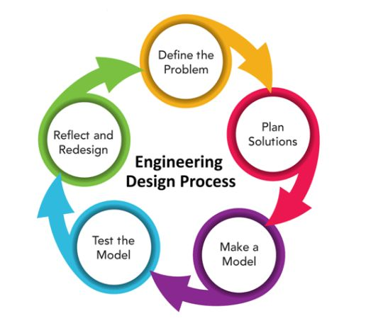Head Teacher Industrial Arts – Rav Pillay

* Year 7 & 8 Wood working
* Year 8 Engineering
* Year 9 Timber
* Year 10 Engineering, problem solving and solutions.
* Year 9 & 10 Graphcs.

Guest Speakers – Rowena Assaad Vesna Rutonjic

Community Connections Manager Core Community

* 47 years in operation – started in Cabramatta as a service for adult English classes
* 200 staff & 5 services - pre-school, aged & disability, youth, settlement, community connections
* Community connections – 3 neighbourhood centres Mt Pritchard, Canley Heights, Miller
* Adult program 25 yrs+, children 5yrs to 12 yrs
* Available for youth also to answer questions
* Programs – school holiday activities, after school activities, social participation programs
* Beginner to advanced, children’s activities
* For example first aid, white card training
* Food Pantry program to support struggling families – one off food hamper based on need
* A poster for a conversation

  Description automatically generatedFinancial support – no interest loan for over 25 yrs old, up to $1,000 for people on Centrelink payments – can buy a laptop, fridge etc – pay back minimum of $20 fortnightly
* VR – school holiday activities – soccer, tennis classes
* Adult activities at schools – primary school, education courses are during school hours – advertised in primary schools
* Facebook posts with updates of programs
* 2 aged care courses running now, and RSA course
* Support people with problems with Centrelink
* Practical experience for certain courses at Core Community

STUDENT REPRESENTATIVE COUNCIL

* Food Fest – SRC sales were very successful. Over $500, create new mural for canteen Toilets.
* Year 12 finish in 2 Weeks – lots of activities before the HSC – fantastic student leaders representing the school.
* **STUDENT COMMENTS**
* ATAR doesn’t’ define you, it’s the friends you make.
* All the teachers have watch us grow, ups and downs thanks to Mr Erskine and all the staff.
* Subjects you do at school, don’t mean that’s what you have to b or what you do, it’s the work ethic you learn from doing the hard work.
* Teachers helped me discover what I really want to do.
* Experience of the whole school community has been great at CHS to shape students for the future.

**Next School council Meeting:**  **Wednesday 6/11/2024**

**Raffle: Raised $146.50**